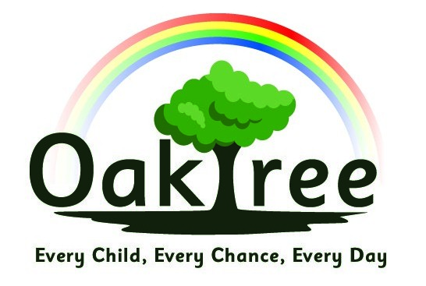

Oaktree Nursery & Primary School

Anti-Bullying Policy

Rationale
At Oaktree our mission statement is ‘Every Child, Every Chance, Every Day’ and this underpins everything that we do. We believe very strongly that all children should come to school to feel safe and listened to and we work hard to create a happy, safe and caring learning environment.

Definitions
Bullying is behaviour which is intended to hurt, threaten or frighten someone else. It damages individual children.
It is deliberately hurtful behaviour repeated over a period of time. Ofsted defines bullying as aggressive or insulting behaviour by an individual or group, often repeated over a period of time that intentionally hurts or harms. It is difficult for victims to defend themselves against it. Bullying can include:
- Name calling
- Verbal harassment
- Malicious gossip
- Teasing
- Intimidation (verbal or physical)
- Ganging up on an individual
- Ostracising
- Theft
- Damaging someone’s property
- Hurting someone physically
- Extortion
- Cyber-bullying

Policy Aims
Bullying is wrong and damages individual children. We therefore do all we can to prevent it, by creating a school ethos in which bullying is regarded as unacceptable. We aim as a school to provide a safe and secure environment where all can learn without anxiety, and where measures are in place to reduce the likelihood of bullying. This policy aims to produce a consistent school response to any bullying incidents that may occur. We aim to make all those connected with the school aware of our opposition to bullying, and we make clear each person’s responsibilities with regard to the eradication of bullying in our school.

Policy into practice

Bullying is taken very seriously and is not acceptable behaviour. Every incident of alleged bullying is discussed with the children concerned and the member of staff will decide as to whether the incident does constitute bullying. Bullying is a word often used by children to describe an argument between two pupils and it is important that all children fully understand that bullying is repetitive and persistent targeting, either verbal or non-verbal, of another child with the intention of causing harm or distress. This message is communicated through assemblies, circle time, Rainbow groups and PSHE lessons and is reinforced by all members of staff.

When a more serious incident has occurred or bullying is persistent, the Headteacher will inform parents or carers and it may lead to exclusion. Any bullying that is judged to be a racist incident will be logged by the school and parents are informed. Children who are judged to be at risk of bullying or being bullied may be referred to Rainbow Room for nurture intervention, or for other interventions such as Circle of Friends. Restorative justice techniques may be used to help to resolve any issues between children.

All incidents of bullying are recorded on CPOMS and the Headteacher, Designated Safeguarding Lead and Nurture Leader are alerted.

Links to other policies
This policy should be read in conjunction with the following policies:
- PSHE
- E-Safety
- Equality
- Behaviour

Date agreed:

Signed:

Headteacher: S Rees Date: September 2024

Chair of Governors: E Milsom Date: September 2024

Date of Review: September 2025

